PROJECT REPORT ON
Invoice Generator
Submitted By

Thanki Chirag Jitendrakuma
[SPU ID No: 2024006083]
[MSCIT SEM: 4] Academic Year 2024-2025 Guided By
Dr. Jyotsna k Salet Submitted To
Department of Computer Science

SHRI V.J. MODHA COLLEGE OF INFORMATION
TECHNOLOGY M.G. Road Opp. Khijadi Plot, PORBANDAR -360575

ACKNOWLEDGMENT

During the preparation of the project, we have a good fortune of receiving support, in various ways, from several personal, numerous to mention here. We owe a debt of gratitude to all of them.

It is our privilege to express our sincerest regards to our project coordinator, Dr. Jyotsna k Salet, for their valuable inputs, able guidance, Encouragement, whole-hearted cooperation and constructive criticism throughout the duration of our project.

We deeply express our sincere thanks to our Dr. Jyotsna k Salet for Encouraging and allowing us to present the project on the topic TASKIFY APPLICATION.

It is our great pleasure to represent our project as one application titled “TASKIFY APPLICATION” and which we conceived in the 4^{rth} semester of MSCIT’ Computer in Application Affiliated with BKNMU (Bhakta Kavi Narsinh Mehta University).

We take this opportunity to thank all our lecturers who have directly or indirectly helped our project. We pay our respects and love to our parents and all other family members and friends for their love and encouragement throughout our career. Last but not the least we express our thanks to our friends for their cooperation and support.

We are also thankful to the BKNMU (Bhakta Kavi Narsinh Mehta University).For including this project development subject in our syllabus. We got a golden opportunity to test and implement our creativity and programming skill simultaneously. Lastly, we would like to extend our sincere thanks to our advisors, classmates as well as all the books and application that have directly or indirectly helped us

ABSTRACT

TaskiFy is a comprehensive task management and productivity application designed to meet the needs of individuals, teams, and organizations. The platform provides an all-in-one solution for organizing, tracking, and managing daily activities, projects, and long-term goals. With an emphasis on usability and performance, TaskiFy delivers a seamless user experience through features like smart to-do lists, recurring tasks, calendar integration, deadline notifications, collaborative workspaces, and progress visualization.

One of the core strengths of TaskiFy lies in its real-time collaboration capabilities, allowing users to assign tasks, share updates, and communicate directly within the app. Whether used for personal productivity, academic planning, or business project coordination, TaskiFy adapts to various user needs with customizable task categories, color-coded priorities, and flexible views (list, board, calendar, or timeline).

From a technical perspective, TaskiFy can be built using modern web technologies such as React or Vite.js for the frontend, Node.js for the backend. The system architecture supports cross-platform functionality, enabling access from desktops, tablets, and mobile devices with offline support.

TaskiFy not only aims to help users manage their tasks efficiently but also promotes productivity habits through features like goal setting, analytics dashboards, and motivational nudges. Future enhancements may include AI-powered suggestions, time tracking, and integrations with third-party services like Calendar.

In essence, TaskiFy combines the power of task organization with collaborative efficiency, offering a scalable and flexible platform for users seeking to take control of their time and work smarter every day.

INDEX

Sr. No. | Topic Name
1. | Chapter No: 1 – Introduction  - Project Summery  - Purpose  - Scope  - Technology & Literature Review
2. | Chapter No: 2 - Project management  - Project Planning and Scheduling
3. | Chapter No : 3 -Formal Specification and Requirement Gathering  3.0 Formal Specification  3.1 Requirement Gathering
4. | Chapter No: 4 - System Analysis  - Analysis (SDLC)  - Design

5. | Chapter No: 5 – Screen Shots  - Screen Shots  - Admin Side  - Client Side
6. | Chapter No: 6 - Conclusion, Limitations And Future enhancement  - Conclusion 6.2Limitations  6.3Further Enhancement
7. | Chapter No:7-Appendices  - References  - Bibliography

Chapter No: 1 Introduction

  - Project Summery
  - Purpose
  - Scope
  - Technology & Literature Review

  - Project Summary

Taskify is a task management web application designed to simplify task organization and improve productivity. It allows users to log in using Google Auth0, create and manage tasks across different statuses such as Pending, In Progress, Completed, Deferred, and Deployed. A dashboard provides an overview of all tasks and their current states, with additional access to statistics and a contact page.

  - Purpose

The purpose of Taskify is to streamline the task-tracking process by providing a user-friendly, cloud-based platform. It empowers users to manage their daily workflows efficiently and gain insights into task progress through visual stats
.
  - Scope

Taskify is ideal for individual professionals, students, and small teams who want to track task statuses in a clean, accessible, and efficient way. The core features include:

- Google Auth0 login
- Dashboard overview
- Task creation and status updates
- Task status categories: Pending, In Progress, Completed, Deferred, Deployed
- Task statistics visualization
- Contact Us form

1.4 Technology & Literature Review
- Frontend: React.js / Next.js
- Backend: Node.js / Express.js
- Authentication: Google Auth0

React.Js/ Next.Js :
React.js
React.js is a powerful, open-source JavaScript library developed and maintained by Meta (formerly Facebook). It is primarily used for building fast, dynamic, and responsive user interfaces—especially single-page applications (SPAs). React follows a component-based architecture, allowing developers to build reusable UI components that manage their own state.

Key Features:
- Virtual DOM: React updates the UI efficiently by only rendering components that actually change.
- Component-Based: Encourages modular, maintainable code.
- Unidirectional Data Flow: Simplifies data management and debugging.
- Hooks & State Management: Allows functional components to handle state and side effects.
Why React.js in Taskify:
- Dynamic task UI updates
- Real-time dashboard rendering
- Component reuse for tasks and status cards
- Better maintainability and scalability

Next.js
Next.js is a React framework developed by Vercel that adds powerful features such as server-side rendering (SSR), static site generation (SSG), API routes, and more. It enhances performance and SEO capabilities while maintaining the flexibility of React.

Key Features:
- Server-Side Rendering (SSR): Renders pages on the server for faster initial load and better SEO.
- Static Site Generation (SSG): Pre-renders pages at build time for even faster delivery.
- API Routes: Built-in backend logic without needing a separate server.
- Routing System: File-based routing for intuitive navigation.
- Optimized Performance: Automatic code splitting and image optimization.

Why Next.js in Taskify:
- Fast page loads and better SEO for public pages (e.g., Contact Us)
- Easy-to-implement routing for dashboard and task views
- Built-in backend routes for handling API calls (e.g., task CRUD operations)
- Simplifies deployment with platforms like Vercel

Combined Power in Taskify
Using React.js with Next.js, Taskify benefits from a highly interactive frontend along with the performance and scalability of server-rendered pages. This combination ensures a smooth user experience while keeping development efficient and future-ready.

Node.js
Node.js is an open-source, cross-platform runtime environment that allows developers to execute JavaScript on the server side. Built on Chrome's V8 JavaScript engine, Node.js is known for its non-blocking, event-driven architecture, which makes it ideal for building scalable and efficient web applications.

Key Features:
- Asynchronous & Non-blocking I/O: Handles multiple requests concurrently.
- Fast Execution: Powered by the V8 engine, ensuring high performance.
- Cross-platform: Runs on Windows, Linux, and macOS.
- npm Ecosystem: Massive library of reusable packages and modules.

Why Node.js in Taskify:
- Enables real-time communication between frontend and backend.
- Supports RESTful APIs for tasks, authentication, and data retrieval.
- Handles multiple users and requests efficiently.

Express.js
Express.js is a minimal and flexible web application framework built on top of Node.js. It simplifies backend development by providing a powerful set of features for building APIs and web servers.

Key Features:
- Simple Routing: Easily define routes for handling HTTP methods (GET, POST, PUT, DELETE).
- Middleware Support: Customize the request-response cycle with middleware functions.
- Lightweight & Fast: Minimal overhead and optimized for performance.
- RESTful API Support: Ideal for building APIs to interact with frontend clients.

Why Express.js in Taskify:
- Manages all backend routes for tasks and user interactions.
- Handles authentication workflows in coordination with Auth0.
- Provides APIs for task creation, status updates, and statistics.
- Acts as the bridge between the frontend (React/Next.js) and the database (e.g., MongoDB).

Node.js + Express.js in Taskify
Together, Node.js and Express.js form the backend engine of Taskify. Node.js provides the runtime, and Express.js adds the structure and routing needed to handle the logic behind user actions like logging in, adding tasks, updating task status, and retrieving data for the dashboard.

Google Auth0 Login :
Auth0 is a flexible, drop-in solution to add authentication and authorization services to applications. It simplifies the process of integrating secure login systems without having to build them from scratch. Google Auth0 Login is an implementation of OAuth 2.0 and OpenID Connect (OIDC) that allows users to log in to an application using their existing Google account credentials.

Key Features:
- Single Sign-On (SSO): Users can log in across multiple apps using one Google account.
- Secure & Reliable: Auth0 handles token management, user sessions, and security best practices such as encryption and rate-limiting.
- User Profile Access: With proper permissions, developers can access the user’s name, email, and profile picture.
- Minimal Setup: Developers only need to configure a client ID and redirect URI via the Auth0 dashboard and Google Cloud Console.

How It Works:
- The user clicks "Login with Google" on the website.
- Auth0 redirects the user to Google for authentication.
- Upon successful login, Google returns an access token and ID token to Auth0.

- Auth0 verifies the tokens and redirects the user back to the application.
- The application receives the user profile and grants access.

Technologies Involved:
- OAuth 2.0 – Authorization framework used by Auth0 and Google
- OpenID Connect (OIDC) – Identity layer on top of OAuth 2.0
- JWT (JSON Web Tokens) – Used to securely transmit user information

Benefits for Taskify:
- Fast and Secure User Onboarding
- No Need for Custom Login System
- Scalable and Future-Proof Authentication

- Other Tools: Chart.js / D3.js (for statistics), Tailwind CSS
The system design is inspired by agile development and modern task tracking methodologies like Kanban and GTD (Getting Things Done).

Chapter No: 2 Project management

  - Project Planning and Scheduling
  - Grant Chart

2.1 Project Planning
The development of Taskify followed an agile methodology with iterative sprints. Key planning stages included:
Requirement Gathering
Requirement Gathering is the process of collecting information from stakeholders, users, and business analysts to understand what the system should do. It is one of the most critical phases in the software development lifecycle, as it lays the foundation for design, development, and testing.
Purpose:
The main goal is to identify functional and non-functional requirements of the system. This includes what features the system should have, how users will interact with it, and any constraints or performance expectations.

Methods Used in Taskify:
- Stakeholder Interviews: Discussions with potential users and project supervisors to understand needs.
- Questionnaires & Surveys: Collected inputs on how users typically manage tasks.
- Competitive Analysis: Studied features of existing task management tools.
- Use Case Scenarios: Created user stories to visualize real-world use of Taskify.
Outcome:
Based on requirement gathering, the key features defined for Taskify include:
- Google-based login (Auth0)
- Adding, editing, and deleting tasks
- Managing task statuses (Pending, In Progress, Completed, etc.)
- Viewing task statistics
- Contact support via form
UI/UX Prototyping
UI/UX Prototyping is the process of designing and simulating the user interface (UI) and user experience (UX) before the actual development of a web application begins. It helps visualize the structure, flow, and interactions of the app, ensuring that it aligns with user needs and expectations.
Purpose:
- To plan the layout and navigation of the application
- To test the look and feel of the interface
- To gather early feedback and make improvements before coding
- To ensure a smooth and intuitive user experience
Tools Used in Taskify:
- Figma – For designing wireframes and interactive prototypes
- Adobe XD / Canva (optional) – For UI mockups
- User Feedback – Collected during early-stage reviews

Key Prototypes Created:
- Login Page: Clean and simple Google sign-in interface
- Dashboard Layout: Overview of all task categories and statistics
- Task Management Interface: Add/edit/delete task functionality
- Task Status Cards: Visual blocks for Pending, In Progress, Completed, etc.
- Contact Us Page: Form with fields for name, email, and message
Benefits:
- Early detection of design flaws
- Better collaboration between designers and developers
- Saves time and resources during the development phase

Frontend & Backend Development
In modern web applications like Taskify, development is divided into two main parts: Frontend (client-side) and Backend (server-side). Each plays a crucial role in delivering a seamless and responsive user experience.

Frontend Development
Frontend development focuses on the visual aspects of the application that users interact with directly. It includes layouts, buttons, navigation, and real-time updates of task information.

Technologies Used:
- React.js / Next.js: For building dynamic and reusable UI components
- Tailwind CSS: For fast, utility-based styling
- Chart.js: For visualizing task statistics
- Axios / Fetch API: For communicating with the backend

Key Frontend Features:
- Google Auth0 login integration
- Interactive dashboard with task stats
- Forms for adding and editing tasks
- Task status UI (Pending, In Progress, Completed, etc.)
- Responsive design for multiple screen sizes

Backend Development
Backend development manages the logic, database operations, APIs, and authentication. It ensures that data flows securely and efficiently between the frontend and the database
Technologies Used:
- Node.js: Server runtime environment
- Express.js: Web framework to define routes and middleware
- MongoDB / Firebase (optional): Database for storing user and task data
- Auth0 Integration: To handle authentication and authorization
Key Backend Features:
- RESTful APIs for CRUD operations on tasks
- Authentication handling via Google OAuth (Auth0)
- Data storage and retrieval for user sessions and tasks
- Validation and error handling for user input

Integration:
Frontend and backend communicate via API calls. For example:
- When a user adds a task, the frontend sends a POST request to the backend.
- The backend processes and stores the data in the database.
- The frontend then updates the UI to reflect the new task.

Testing & Debugging
Testing and Debugging are critical phases in the software development lifecycle that ensure the application runs smoothly, meets user requirements, and is free of critical issues or bugs before deployment.

Testing
Testing is the process of evaluating the functionality of a software application to identify errors, gaps, or unmet requirements. It ensures that the system performs as expected across different scenarios.

Types of Testing Used in Taskify:
- Functional Testing: Checked if task creation, editing, and deletion work properly.
- UI Testing: Ensured that buttons, forms, and dashboards behaved correctly.
- Integration Testing: Verified communication between frontend and backend (e.g., API calls).
- Authentication Testing: Tested Google Auth0 login flow and session management.
- Cross-Browser Testing: Ensured compatibility with Chrome, Firefox, and Edge.
Tools Used:
- Postman: For testing API endpoints
- Chrome DevTools: For inspecting and testing frontend UI
- Console Logging: To trace logic flow and outputs

Debugging
Debugging is the process of identifying, analyzing, and fixing issues or bugs in the code. It plays a crucial role in refining the application's performance and reliability.

Common Debugging Techniques in Taskify:
- Console Logs: Used to trace variable values and application flow
- Error Stack Traces: Analyzed to identify the source of backend and frontend issues
- Code Review: Peer reviews to catch potential bugs and code improvements
- Real-time Monitoring: Observed network requests and responses using browser tools

Goal of Testing & Debugging:
- Ensure reliability, performance, and user satisfaction
- Catch and fix issues before deployment
- Improve code quality and maintainability

- Deployment
Deployment is the final stage in the development process, where the application is moved from a development or testing environment to a live server where it becomes accessible to users. It ensures that the system is available online and functions correctly in a production setting.

Deployment Process for Taskify
Taskify was deployed to make it publicly accessible with a reliable and scalable hosting solution. Below is the standard deployment flow followed:
Steps Followed:
- Build Optimization:
  - Used next build (for Next.js) to optimize the app for production.
  - Minified code and optimized static assets for faster load times.
- Hosting Platform:
  - Deployed using Vercel, a platform built for seamless deployment of Next.js applications.
  - Alternative hosting options like Netlify or Render could also be considered.
- Backend Hosting:
  - Express.js backend deployed via platforms like Render or Heroku.
  - Ensured environment variables (e.g., Auth0 credentials) were securely configured.
- Authentication Setup:
  - Configured production callback URLs in Auth0 to ensure login works after deployment.
- Domain & SSL:
  - Custom domain setup (optional).
  - SSL certificate auto-configured via Vercel for secure HTTPS connection.

Benefits of Deployment:
- Allows real users to access and interact with Taskify
- Enables real-time bug identification and performance monitoring
- Opens the door for feedback, iteration, and scalability

2.2 Project Scheduling
Phase | Timeline
Requirement Analysis | Week 1
Design & Mockups | Week 2
Development | Weeks 3 - 6
Testing | Weeks 7 - 8
Deployment | Week 9
Documentation | Week 10

Chapter No: 3 Formal Specification and Requirement Gathering

Formal Specification and Requirement Gathering

  - Formal Specification
  - Requirement Gathering

3.1 Formal Specification

Taskify is designed to meet the following functional requirements:

- Users must be able to log in using their Google accounts.
- Users can add, edit, and delete tasks.
- Tasks can be categorized into specific statuses.
- The dashboard must visually display task stats.
- Contact form should allow users to reach out for support.

3.2 Requirement Gathering

Requirements were gathered through:

User surveys

- A User Survey is a technique used during the early stages of software development to collect feedback, expectations, and preferences directly from potential users. It helps developers and project managers understand real-world needs, identify user pain points, and shape the features and design of the application accordingly.

Purpose of the User Survey in Taskify

- For Taskify, the user survey was conducted to:
- Understand how users currently manage their daily or project tasks
- Identify common problems faced with existing task management tools
- Gather suggestions for features, such as task statuses, reminders, and analytics
- Assess the importance of features like Google login, dashboard stats, and mobile-friendliness

Survey Format:
- The survey included a mix of:
- Multiple Choice Questions (MCQs) – e.g., "How often do you use a task manager?"
- Rating Scales – e.g., "Rate the importance of viewing task statistics (1 to 5)"
- Open-Ended Questions – e.g., "What feature would you most like to see in a task manager?"

Insights Gained:

- Users prefer Google login over creating a new account
- Majority want to track tasks by status (Pending, In Progress, Completed, etc.)
- Many users appreciate a dashboard view with task stats
- A simple and clean UI was highly requested

Outcome:

The feedback collected through the survey played a key role in shaping the feature set and interface design of Taskify, making it more user-centric and practical for everyday use.

Competitor analysis

Competitor Analysis is the process of researching and evaluating similar products or services in the market to understand their strengths, weaknesses, features, and user experience. It helps identify opportunities to differentiate and improve your own application.

Purpose of Competitor Analysis in Taskify The main goals of conducting a competitor analysis for Taskify were to:

- Understand what features are standard in task management apps
- Identify gaps or pain points in existing solutions
- Gain inspiration for UI/UX design and core functionality
- Ensure Taskify offers a unique value proposition

Competitors Studied:

- Trello

  - Kanban board interface
  - Good for team collaboration
  - Lacks detailed task statistics and analytics

- Todoist

  - Simple and clean UI
  - Great for personal task tracking
  - Limited in visual representation of progress

- Asana

  - Powerful for project management
  - Heavy and complex for basic users
  - More focused on teams than individuals

- Microsoft To Do

  - Integrated with other Microsoft products
  - Lacks flexibility in task categorization
  - Limited task status tracking

Key Takeaways:

- Most competitors lack lightweight task analytics/statistics dashboards
- Many tools are too complex for individual users or casual task tracking
- Google login is not always available by default
- Simple status-based task filtering (e.g., In Progress, Deferred) is often underdeveloped

How Taskify Stands Out:

- Provides an easy-to-use dashboard with visual task statistics
- Focused on individual users and students, not just teams
- Supports multiple task statuses like Pending, In Progress, Deferred, and Completed
- Google Auth0 login simplifies onboarding

Stakeholder meetings

Stakeholder meetings are collaborative sessions held with individuals or groups who have a vested interest in the success of a project. These stakeholders may include clients, users, developers, project managers, and supervisors. The purpose is to align the project goals with the actual needs, expectations, and feedback of the people who will use or be impacted by the system.

Purpose of Stakeholder Meetings in Taskify For Taskify, stakeholder meetings were conducted to:
- Discuss the initial idea and project vision
- Define key functionalities and user expectations
- Validate requirements gathered through surveys and research
- Receive feedback on wireframes and prototypes
- Ensure the application aligns with academic and real-world usability standards

Stakeholders Involved:

- Project Supervisor/Instructor: Provided academic direction and scope validation
- Target Users (Students, Professionals): Shared task management habits and preferences
- UI/UX Designers (if involved): Offered insights into usability and layout
- Developers: Discussed technical feasibility and planning

Meeting Outcomes:

- Finalized the list of core features (task statuses, dashboard, Google login)
- Agreed on using modern tech stack (React/Next.js, Node.js, Express.js)
- Gathered feedback that led to design improvements
- Set realistic development timelines and priorities

Tools Used:

- Google Meet / Zoom for virtual meetings
- Google Docs / Notion for sharing notes
- Figma for live prototype walkthroughs

Importance:

Stakeholder meetings helped ensure that Taskify was developed with a clear vision, reducing the risk of scope creep, unnecessary features, or misalignment with user needs.

Prototype Feedback

Prototype feedback is the process of gathering user and stakeholder reactions to early design versions (prototypes) of the application. These prototypes are interactive mockups or wireframes that simulate how the final application will look and function. The feedback collected during this phase is crucial for improving usability, refining features, and ensuring the product meets user expectations before development begins.

Purpose of Prototype Feedback in Taskify For Taskify, the main objectives of collecting prototype feedback were to:

- Validate the UI/UX design choices
- Identify confusing or unnecessary elements in the layout
- Refine task flows such as adding, editing, and tracking tasks
- Ensure the interface is user-friendly and accessible

Prototypes Created:
- Login Page (with Google Auth0 flow)
- Main Dashboard with task summaries
- Task Status Sections (Pending, In Progress, Completed, etc.)
- Add/Edit Task Forms
- Contact Us Page

Feedback Sources:
- Target Users (students, individual task managers)
- Project Supervisors
- Peers & Team Members
- UI/UX Reviewers (optional)

Common Feedback Received:
- Simplify the task form by reducing fields
- Make task status colors more intuitive (e.g., red for pending, green for completed)
- Add visual charts for better task overview
- Improve mobile responsiveness for better accessibility

Outcome:
Based on the feedback, several improvements were made:
- Dashboard layout was made cleaner and more responsive
- Task cards were redesigned for better readability
- Navigation was simplified for smoother user flow
- Added task analytics section for better task tracking

Importance:
Prototype feedback helped reduce development time, avoid unnecessary rework, and create a better user experience by ensuring that the design was user-approved before any code was written.

Chapter No: 4 - System Analysis

  - Analysis (SDLC)
  - Design
    - Use case Diagram
    - Data Dictionary

4.1 Analysis

The system focuses on ease of use, quick task creation, and clear visual feedback. The main modules include:
Auth Module:

The Authentication Module is a crucial part of any secure web application. It handles the process of verifying users' identities and ensuring that only authorized users can access specific features or data. In Taskify, the Auth Module was implemented using Auth0 with Google Sign-In, allowing users to log in quickly and securely without creating a separate account.

Purpose of the Auth Module in Taskify

- To enable secure and smooth login for users
- To prevent unauthorized access to user-specific data (like personal tasks)
- To manage user sessions and authentication tokens

Technologies Used:

- Auth0: A secure authentication-as-a-service platform
- Google OAuth 2.0: For logging in with Google accounts
- JWT (JSON Web Tokens): For secure token-based authentication
- Next.js API Routes / Express.js: To handle backend auth verification

Features:
- Google Sign-In Integration
- User Profile Retrieval (name, email, picture)
- Session Management (login/logout)
- Protected Routes to restrict access to dashboard and tasks
- Token Handling for verifying user identity across frontend and backend

Security Benefits:

- Reduced risk of password-based attacks
- Centralized user identity management
- Automatic token expiration and renewal handling by Auth0

Outcome:

With the Auth Module, Taskify offers a frictionless login experience while keeping user data safe and private. It sets the foundation for secure task management and personalized dashboards.

Task Management Module :

The Task Management Module is the core functionality of the Taskify application. It enables users to create, organize, and track their tasks efficiently based on their current progress and status. This module is designed to simplify task handling for individual users by providing a clear, categorized, and interactive interface.

Purpose of the Task Management Module in Taskify

- To allow users to add, edit, delete, and organize tasks
- To visually track the progress of each task through different statuses
- To provide insights on task completion and workload through task statistics

Features:

- Add New Task: Users can create new tasks with a title, description, due date, and status
Task Status Categories:

  - Completed Tasks
  - Pending Tasks
  - In Progress Tasks
  - Deferred Tasks
  - Deployed Tasks

- Edit/Delete Tasks: Modify task details or remove them when no longer needed
- Status Update: Easily move tasks between categories based on progress
- Task Statistics Dashboard: Visual summaries showing how many tasks are in each status
- Responsive UI: Works across desktop and mobile devices

How It Works:

- Tasks are stored in a backend database (e.g., MongoDB)
- Frontend displays tasks in sections based on their status
- CRUD operations (Create, Read, Update, Delete) are performed via API endpoints using Axios/Fetch
- State management (React hooks or context) ensures real-time updates to the task list

Integrated With:

- Auth Module: Only authenticated users can access and manage their own tasks
- Dashboard Module: Shows real-time task status summaries and charts

Outcome:

The Task Management Module empowers users to stay organized, manage workloads effectively, and maintain focus by visually tracking progress — making Taskify a smart personal task tracking tool.

Dashboard Stats Module :

The Dashboard Stats Module in Taskify provides users with a quick, visual overview of their task progress. This module summarizes task data in real-time and displays it in an easy-to-understand format, helping users stay informed, motivated, and organized.

Purpose of the Dashboard Stats Module

- To provide a summary view of all task statuses (e.g., Pending, In Progress, Completed)
- To help users track productivity and progress over time
- To offer visual insights that improve time management and task planning

Key Features:

- Task Count Overview: Displays the number of tasks in each
category:

  - Pending
  - In Progress
  - Completed
  - Deferred
  - Deployed

- Visual Charts: Uses bar charts, pie charts, or donut charts to visualize task distribution
- Real-Time Updates: Reflects any changes made to tasks instantly
- User-Specific Stats: Each user sees only their own data after login via Auth0

How It Works:

- Fetches task data from the backend based on the logged-in user's ID
- Aggregates the data by status
- Uses frontend libraries (e.g., Chart.js, Recharts, or built-in Next.js components) to render visual elements
- Updates dynamically when tasks are added, updated, or deleted

Benefits:

- Helps users identify bottlenecks in their workflow
- Encourages better task planning and prioritization
- Makes Taskify more engaging with interactive visuals
- Enhances user experience through clarity and transparency

Outcome:

The Dashboard Stats Module transforms raw task data into actionable insights. By offering a clear visual breakdown of tasks, it supports users in achieving better productivity and making informed decisions — reinforcing Taskify's goal of being a practical and user-friendly task management tool.

Contact Module :

The Contact Module in Taskify provides users with a way to get in touch with the developers or support team. This module allows users to submit feedback, ask questions, report issues, or request additional features, helping improve the application through continuous communication and support.

Purpose of the Contact Module

- To offer users a simple way to communicate with the team
- To collect valuable feedback about the app's usability, features, or bugs
- To build user trust and support engagement

Key Features:

- Contact Form: Includes fields like Name, Email, Subject, and Message
- Form Validation: Ensures all required fields are properly filled
- Email Integration: Sends the message to a designated support/developer email address using backend tools or services (e.g., Nodemailer, Formspree, or EmailJS)
- Success/Failure Alerts: Notifies users whether their message was successfully sent

How It Works:

- The frontend form is built using React/Next.js
- On form submission, the data is sent to a backend API route or external service
- The backend handles email sending and error handling
- The user is shown a success message or prompt to retry in case of failure

Benefits:

- Improves communication between users and developers
- Helps gather feature suggestions or report bugs efficiently
- Makes the platform feel more responsive and user-focused

Outcome:

The Contact Module ensures that Taskify is not just a one-way tool but an interactive platform that listens to its users. It contributes to a more polished, professional, and supportive user experience.

4.2 Design

Design Considerations:

- Clean and minimal UI

The Clean and Minimal User Interface (UI) is a core design philosophy implemented in Taskify. It focuses on simplicity, clarity, and ease of use — ensuring that users can interact with the platform smoothly without distractions or complexity. This approach enhances usability and creates a professional, modern look and feel.

Purpose of a Minimal UI in Taskify

- To make the app easy to navigate, even for first-time users
- To reduce cognitive load by showing only what’s necessary
- To improve focus on key tasks and actions
- To ensure a consistent experience across devices (desktop/tablet/mobile)

Design Principles Followed:

- Flat Design: Avoids unnecessary shadows, gradients, or 3D effects
- Whitespace Usage: Uses spacing to group content and make it breathable
- Consistent Color Scheme: Soft tones and accent colors for status indicators
- Clear Typography: Easy-to-read fonts with appropriate sizing
- Simple Icons: Intuitive icons to represent tasks, statuses, and actions
- Responsive Layouts: Mobile-friendly and accessible on all screen sizes

UI Highlights in Taskify:

- Dashboard: Clean task summaries with subtle charts and icons
- Task List: Organized cards for each task with clear status indicators
- Forms: Minimal input fields with helpful placeholders and labels
- Navigation: Simple sidebar or top menu with icons and smooth transitions

Benefits of a Clean UI:

- Enhances user satisfaction and retention
- Reduces errors and confusion
- Makes the app feel faster and more reliable
- Encourages users to focus on productivity, not learning the interface

Outcome:

The clean and minimal UI in Taskify aligns with modern web standards and user expectations. It creates a seamless experience where users can focus on their tasks without unnecessary distractions, making the tool both beautiful and functional.

Mobile responsiveness

Mobile Responsiveness refers to the website's ability to adapt its layout and functionality across different screen sizes, especially smartphones and tablets. In Taskify, mobile responsiveness was a key design goal to ensure that users can manage their tasks anytime, anywhere — without needing a desktop.

Purpose of Mobile Responsiveness in Taskify

- To make the app accessible on all devices — phones, tablets, and desktops
- To enhance user convenience, allowing task management on the go
- To improve usability and engagement by delivering a consistent experience

Implementation Techniques:

- Responsive Design: Built using CSS Flexbox and Grid to allow dynamic layout adjustments
- Media Queries: Applied breakpoints for different screen widths (e.g., 768px for tablets, 480px for phones)
- Fluid Layouts: Elements like task cards, buttons, and charts scale based on screen size
- Mobile-Friendly Navigation: Hamburger menus or simplified headers for smaller screens
- Touch Optimization: Buttons and interactive elements sized appropriately for touch use

Benefits:

- Users can add or manage tasks quickly from mobile devices
- No need to install a separate app — the web app works like a native mobile app
- Boosts overall user experience, retention, and accessibility

Tested On:

- iOS Safari and Chrome browsers
- Android Chrome browser
- Different device resolutions (desktop, tablet, mobile)

Outcome:

Thanks to its mobile responsiveness, Taskify ensures that users have a seamless experience across all platforms. Whether at home or on the move, they can keep track of their productivity without limitation.

Status color indicators

The Status Color Indicators in Taskify are visual cues that help users quickly identify the current state of their tasks. Each task is associated with a specific color based on its status, making it easier for users to understand and prioritize their workload at a glance.

Purpose of Status Color Indicators

- To provide a quick visual reference for task progress
- To help users differentiate between task categories without reading every label
- To make the interface more intuitive and user-friendly

Status Categories & Their Colors:

- 🟡 Pending: Yellow – indicates tasks that are yet to be started
- 🔵 In Progress: Blue – shows tasks that are currently being worked on
- ✅ Completed: Green – represents tasks that have been successfully finished
- 🔴 Deferred: Red – signals tasks that are delayed or postponed
- 🟣 Deployed: Purple – shows tasks that have been finalized and implemented

Implementation Details:

- Colors are applied using CSS classes or inline styles
- Status badges or tags are displayed on each task card
- Color indicators are consistent across all views: dashboard, task list, and analytics

Benefits:

- Enhances visual clarity and overall UX
- Allows for faster scanning and decision-making
- Adds a professional and polished look to the UI

Outcome:

With its intuitive status color indicators, Taskify ensures that users can manage and understand their tasks more efficiently. This feature improves both functionality and aesthetics, supporting the app's goal of simple and smart task tracking.

Accessible navigation

Accessible Navigation in Taskify ensures that users can easily and efficiently move through the application, regardless of the device they’re using or their level of technical skill. This design choice is focused on usability, simplicity, and inclusivity, allowing all users to interact with the platform without confusion or difficulty.

Purpose of Accessible Navigation

- To provide a seamless and intuitive experience for users of all abilities
- To support keyboard and screen reader navigation
- To make it easy for users to quickly access core features like Dashboard, Tasks, Stats, and Contact

Key Features:
- Clear Navigation Menu: A fixed, easy-to-read navigation bar with labeled links/icons
- Responsive Design: The navigation adapts to both desktop and mobile layouts
  - Desktop: Horizontal or sidebar navigation
  - Mobile: Hamburger menu or collapsible drawer
- Consistent Layout: Navigation remains in the same place across all pages
- Keyboard Accessibility: Navigation can be used via Tab/Enter keys without a mouse
- Highlighting Active Pages: Users can easily see which section they’re currently in
- Accessible ARIA Labels: For screen readers and assistive technologies

Key Sections in Navigation:
- Dashboard
- Add Task
- Task Stats
- Task Categories (Pending, In Progress, Completed, etc.)
- Contact Us
- Logout/Login

Benefits:
- Improves overall usability and user satisfaction
- Supports users with disabilities or limited tech experience
- Ensures compliance with accessibility standards (like WCAG)
- Creates a clean and professional app structure

Outcome:

With accessible navigation, Taskify delivers a smooth, inclusive, and user-friendly experience — allowing users to focus on productivity rather than figuring out how to use the platform.

Tools Used:

Auth0 (for Login activity) :

Auth0 is used in Taskify to handle secure user authentication via Google login. It provides a seamless, secure, and scalable way for users to sign in without managing credentials manually. By integrating Auth0, Taskify ensures reliable identity verification and a smooth login experience.

Mail.js (for Contact) :

In Taskify, the Mail.js file handles the email-sending functionality from the Contact Us form. When a user submits a message through the contact form, the backend processes this data and sends it to the intended recipient using a mail service. This functionality is implemented using Node.js with a mailing library like Nodemailer.

Purpose of Mail.js

- To allow users to send messages directly to the support or development team
- To automate email handling from the website's contact form
- To ensure that messages are reliably delivered without manual steps

How Mail.js Works:

- User fills the contact form (name, email, subject, message)
- On form submission, the data is sent to an API route (e.g., /api/contact)
- The Mail.js file receives this data and:
  - Configures an email service (like Gmail, Outlook, or SMTP)
  - Composes the email with user input
  - Sends the email to the predefined address (e.g., taskify.support@mail.com)
- A success or error response is returned to the frontend

Technologies Used:

- Node.js – Runtime for handling backend logic
- Nodemailer – Library for sending emails
- Environment Variables – To securely store email credentials (SMTP host, port, auth info)
- Next.js API Routes or Express.js – To handle HTTP requests from the frontend

Benefits:

- Automates user-to-admin communication
- Improves support and feedback flow
- Provides a professional and responsive experience for users
- Keeps sensitive contact details hidden from the frontend

Outcome:

The Mail.js file serves as a reliable backend service in Taskify’s Contact Module, enabling real-time communication with users while maintaining security and automation standards.

Tailwind CSS (for styling)

Tailwind CSS is a utility-first CSS framework that is used in Taskify to design responsive, modern, and clean user interfaces. Unlike traditional CSS or component libraries, Tailwind allows developers to style elements directly within the HTML (JSX in React) using predefined utility classes — enabling faster development and greater design consistency.

Purpose of Using Tailwind CSS

- To create a clean and minimal UI quickly and efficiently
- To maintain consistent styling across the entire application
- To simplify the process of building responsive and mobile-friendly layouts
- To avoid bulky custom CSS and keep the codebase modular and scalable

How Tailwind CSS Is Used in Taskify:

- Layout Styling: Grid, Flexbox, spacing (p-4, m-2, etc.)
- Typography: Fonts, text sizes (text-xl, font-semibold)
- Colors & Themes: Task status indicators (bg-green-500, text-yellow-600, etc.)
- Buttons & Forms: Styled directly using utility classes (hover:bg-blue-600, rounded-lg)
- Responsive Design: Media query helpers like md:, lg:, sm: to build mobile-first layouts
- Dark Mode (optional): Tailwind supports dark mode configuration if needed

Benefits:

- Rapid Development: Build UIs faster with no need to switch between HTML and CSS files
- Customization: Easily extendable and themeable via the Tailwind config
- Consistent Design Language: Uniform spacing, font sizing, and color schemes
- Responsive by Default: Automatically adapts to different screen sizes with ease

Example Use:

jsx
CopyEdit
<button className="bg-blue-600 hover:bg-blue-700 text-white font-bold py-2 px-4 rounded">
Add Task
</button>

Outcome:
Tailwind CSS empowers the Taskify frontend with a lightweight, consistent, and professional design, while also speeding up development and keeping the codebase easy to maintain.

Chapter No: 5 Screen shots

  - Screen Shots

Dashboard:

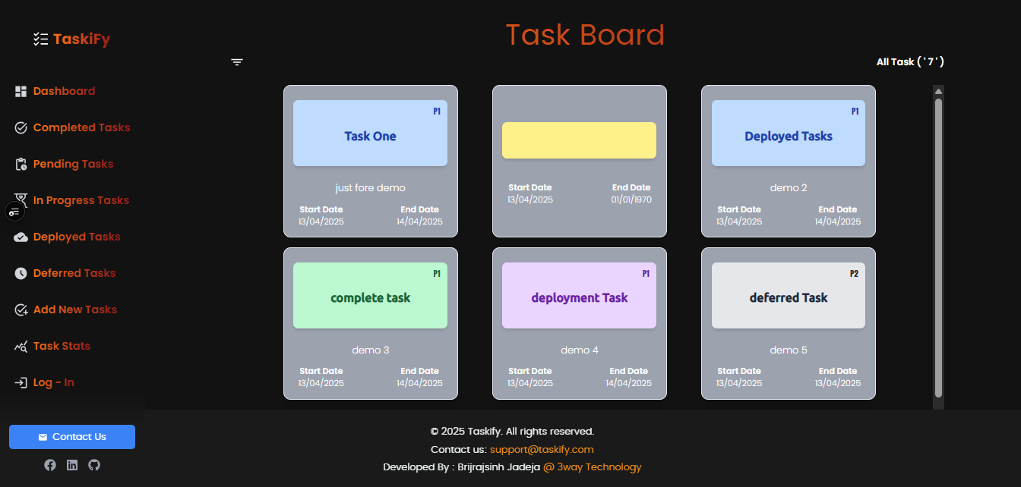

Description :
- This is a dashboard page.
- We can show all tasks in one bord.
- If Task already started then we can see the detail of Task in a card’s.

5.2 Complete Tasks :

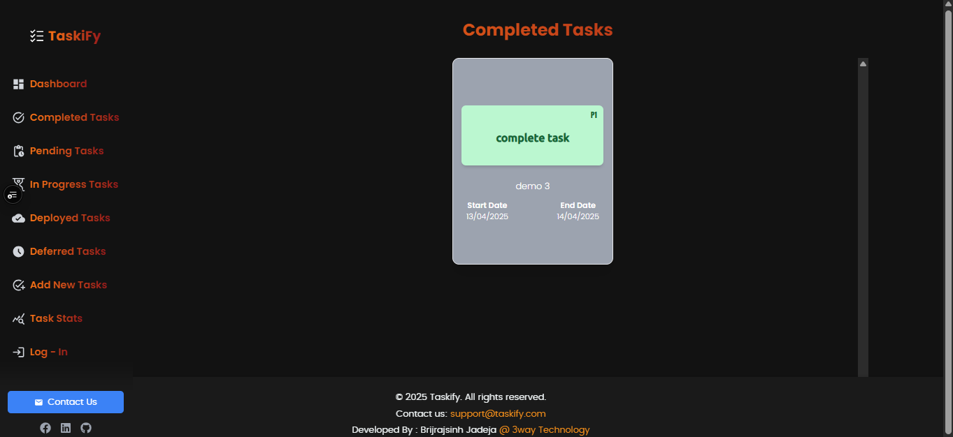

Description:
- This page is show up the complete tasks card
- Complete Tasks show in a green font and green card

5.3 Pending Task

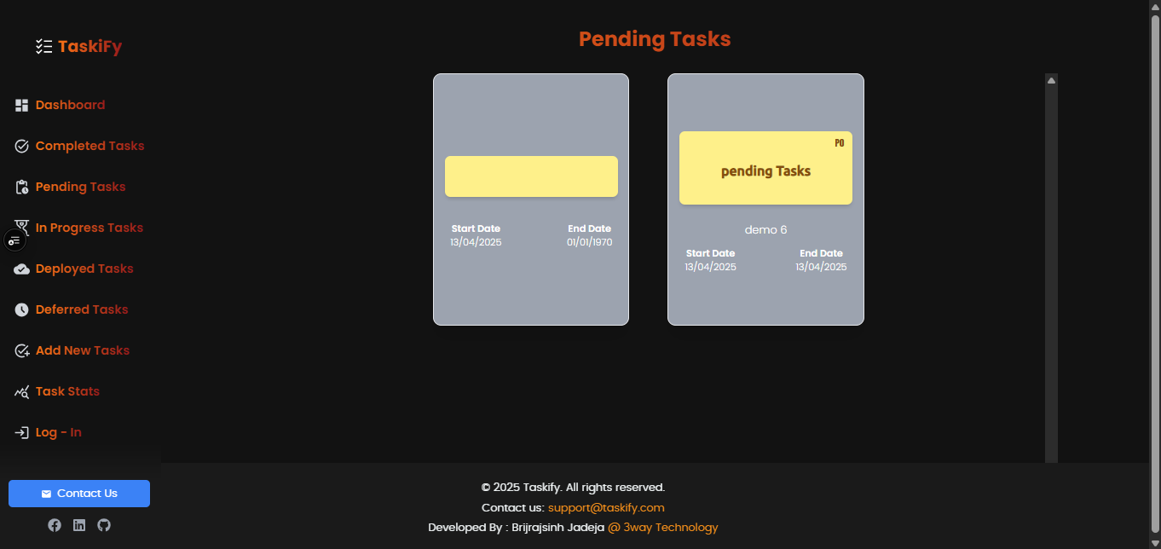

Description:
- This page is a Pending Tasks card’s pages.
- Pending tasks always be shown in brown font and yellow cards

  - In progress Task :

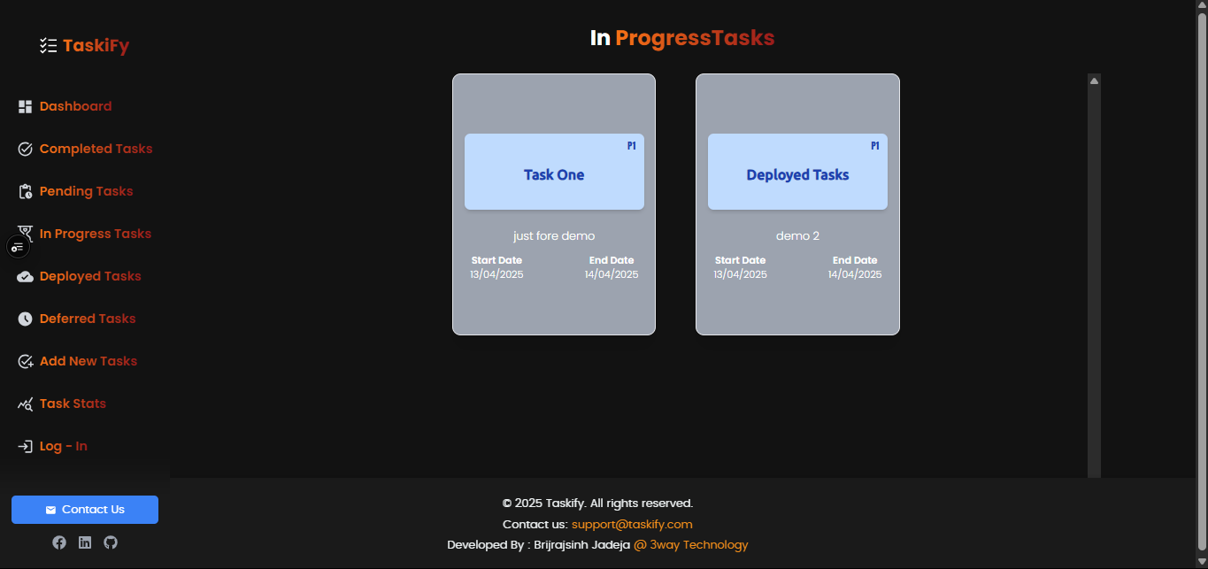

Description:

- This page is displayed a in progress Task.
- In progress task font is blue and the card is grey.

  - Deployed Task:

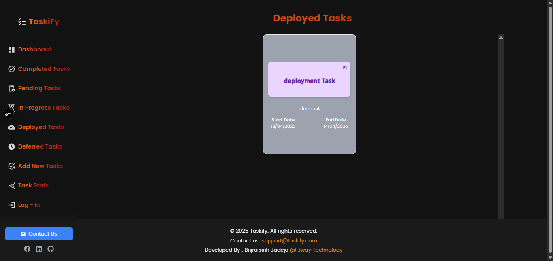

Description:
- The page is display deployed Tasks
- In deployed Tasks front is purple and card is light purple

5.6 Deferred Task

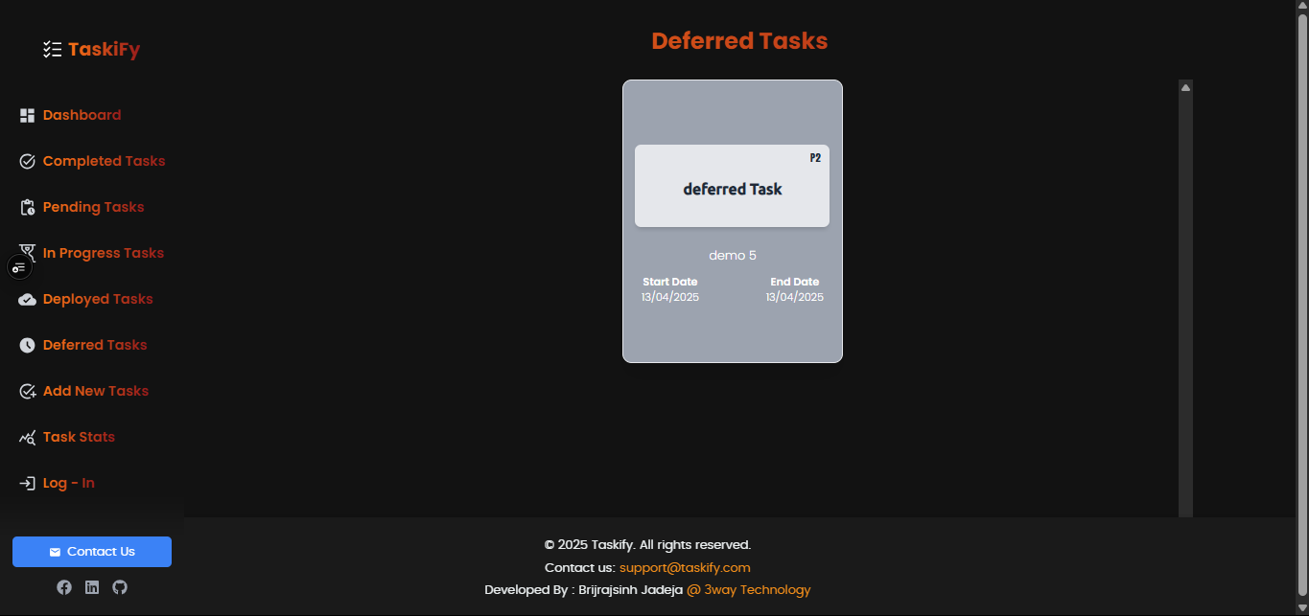

Description:
- The page is display deferred Tasks
- In deployed Tasks front is red and card is light purple

5.7 Task Stas

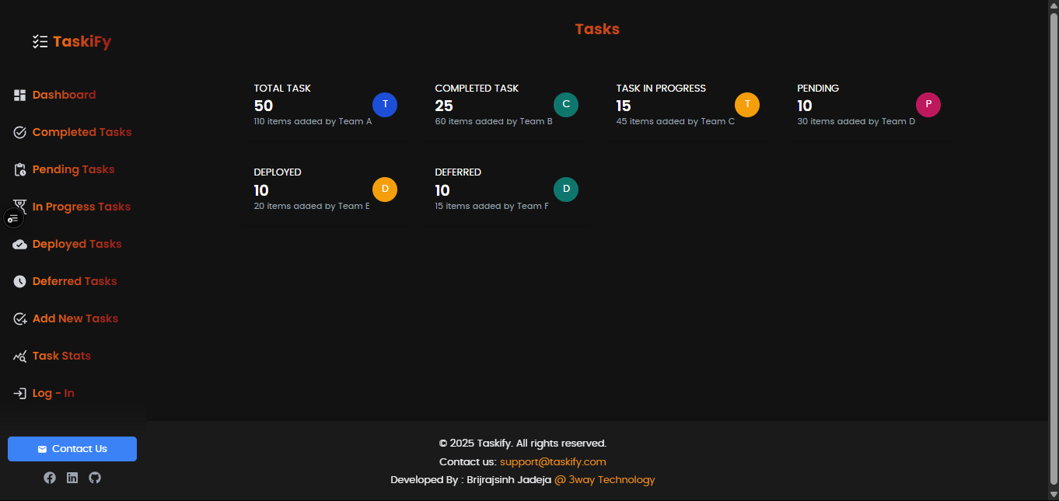

Description:
- This page is about Task Stats page.
- They have been displayed a total of of tasks, completed tasks, in process task, in pending tasks, in deployed task and in deferred task.

  - contact us :

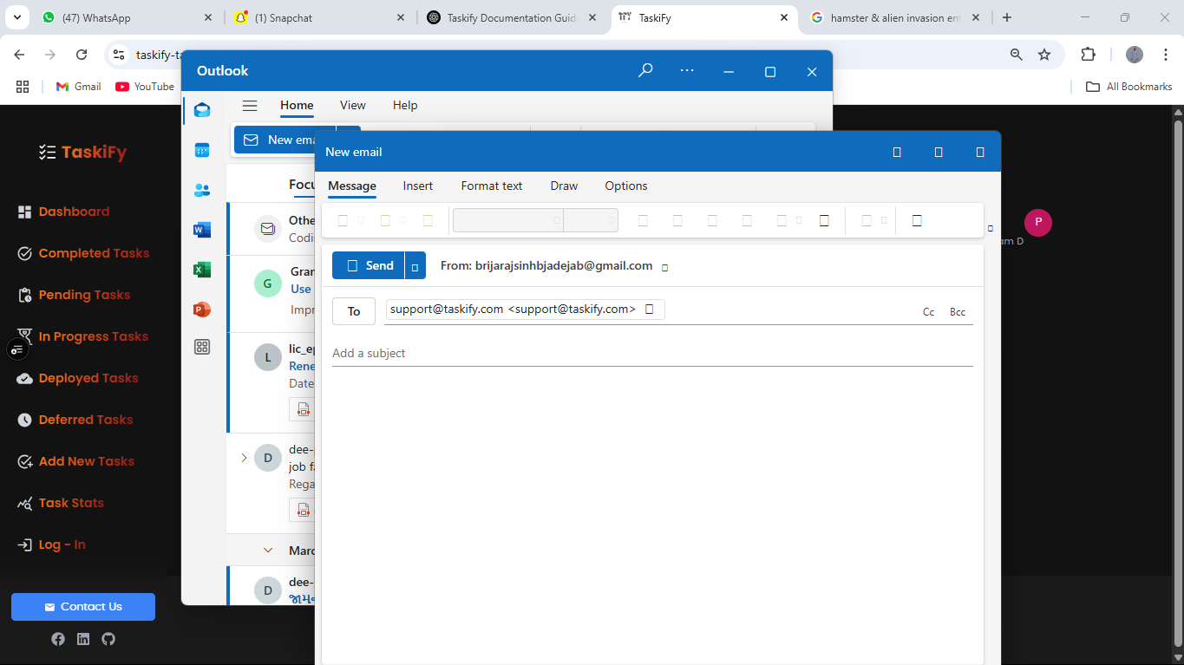
Click here

Description:

- this page about contact us page.
- After click the contact us button then open a mailbox window after the user can contact us.
- User also can send mails, message and some attachments.

Chapter: 6

Conclusion, Limitations And Further enhancement

Conclusion, Limitations And Further enhancement

  - Conclusion
  - Limitations
  - Further Enhancement

6.1 Conclusion

Taskify successfully delivers a streamlined task-tracking solution with modern features, intuitive design, and real-time updates. It addresses the basic needs of users seeking a reliable productivity tool.

The development of Taskify successfully demonstrates how a modern, responsive, and user-friendly task management platform can streamline productivity. By integrating essential features like Google-based authentication, task categorization, real-time status tracking, and a clean UI/UX design, Taskify provides a practical solution for managing everyday tasks efficiently. The project reflects a strong combination of planning, design, development, and user feedback — resulting in a functional and scalable web application that meets the intended goals.

6.2 Limitations :

Limited team collaboration features

While Taskify offers a strong individual task management experience, its current version lacks advanced team collaboration capabilities. Features such as assigning tasks to multiple users, shared workspaces, real-time collaboration, and team chat are either minimal or not implemented. This limits its use for teams or organizations looking for a fully collaborative project management tool.

Current Limitations:

- No multi-user task sharing or assignments
- No real-time collaboration or comments on tasks
- No role-based permissions (e.g., admin, member)
- No team dashboards or group notifications

Future Scope:

These limitations present opportunities for future development. Integrating team collaboration tools would significantly enhance Taskify’s value for professional and organizational use.

No Notifications or Reminders

Currently, Taskify does not include built-in notifications or reminder systems for upcoming or overdue tasks. This limits its effectiveness for users who rely on timely alerts to manage their schedules and stay on top of deadlines.

Limitations Due to This:

- Users must manually check the dashboard to track task progress
- No alerts for pending, overdue, or newly added tasks
- Missed tasks may go unnoticed without proactive user effort
- No email, push, or in-app notifications implemented

Future Scope:

Adding a notification system—via email, push alerts, or real-time in-app messages—could greatly improve user engagement and productivity. This enhancement would help users stay informed and better manage time-sensitive tasks.

- No mobile app version currently

At present, Taskify is only available as a responsive web application and does not have a dedicated mobile app for Android or iOS platforms. While the web app is mobile-friendly, it lacks the full native experience and convenience of a standalone mobile application.

Limitations Due to This:

- Users must access Taskify through a mobile browser
- No support for offline usage or native push notifications
- Reduced performance and accessibility compared to native apps
- Cannot be distributed via app stores (e.g., Play Store, App Store)

Future Scope:

Developing a native or hybrid mobile app would enhance usability, offer offline features, and provide users with a more seamless, app-like experience — further increasing Taskify’s reach and effectiveness.

Chapter No: 7 Appendices

7.1Refeneces 7.2Biblilography

7.1 References
- Auth0 Documentation (https://auth0.com/docs/):

Auth0 Documentation provides comprehensive guides and references for integrating secure authentication and authorization into applications using Auth0. https://auth0.com/docs/

- React Official Docs :
React Official Documentation offers in-depth guides, tutorials, and API references for building user interfaces with React. https://react.dev/

- Tailwind CSS Docs :
Tailwind CSS Documentation provides detailed instructions and examples for using its utility-first CSS framework to build modern, responsive user interfaces. https://tailwindcss.com/docs

